International Conference on the Implications of Information and Digital Technologies for Development (Note – Replace this header with your paper title)

Author Name 1 (Note – To be included only once the submission has been accepted)
Affiliation 1, town/city, Country
Email address 1
ORCID 1
Author Name 2 (Note – To be included only once the submission has been accepted)
Affiliation 2, Town/City, Country
Email address 2
ORCID 2
Author Name 3 (Note – To be included only once the submission has been accepted)
Affiliation 3, Town/City, Country
Email address 3
ORCID 3

Abstract: Insert here your abstract with no more than 150 words.

Keywords: Insert here the keywords for your paper.

Introduction
The accepted papers and the panel statements of the conference are published in the Proceedings. We wish to give the proceedings a consistent, high-quality appearance. We therefore ask that authors follow some basic guidelines. In essence, you should format your paper exactly like this document. The easiest way to use this template is to replace the content with your own material.

Text Length
There is no strict page or word limit, but please use the following guidelines:
- Full Research Papers: 12-15 pages, where a page constitutes 300-400 words
- Research in Progress: 6-11 pages, where a page constitutes 300-400 words

Corresponding Author
The corresponding author – i.e. the author responsible for checking the final proof and for signing the license-to-publish agreement on behalf of all of the authors – should be clearly marked in the header of the paper (after it has been accepted).
It is the responsibility of the corresponding author to ensure that questions related to the accuracy or integrity of any part of the work are appropriately addressed. The inclusion of the corresponding author’s email address is mandatory. In order to streamline communication during the publication process, there should not be more than one corresponding author per paper.

Formatting
Instructions for special formatting follow.

Headings. Headings should be capitalised (i.e. nouns, verbs, and all other words except articles, prepositions, and conjunctions should be set with an initial capital) and should be aligned to the left. Only the first two levels of section headings should be numbered, as shown in Table 1. The respective font sizes are also given in Table 1.

Table 1. Font sizes of headings (Note – Table captions should always be positioned above the tables)
Heading level | Example | Font size and style
Title (centred) | Lecture Notes | 14 point, bold
1st-level heading | 1 Introduction | 12 point, bold
2nd-level heading | 2.1 Printing Area | 10 point, bold
3rd-level heading | Run-in Heading in Bold. Text follows | 10 point, bold
4th-level heading | Lowest Level Heading. Text follows | 10 point, italic

Figures and Tables. It is essential that all illustrations are clear and legible. High resolution is required for the printed proceedings. Vector graphics (rather than rasterised images) should be used for diagrams and schemas whenever possible. Please check that the lines in line drawings are not interrupted and have a constant width. Grids and details within the figures must be clearly legible and may not be written one on top of the other. Line drawings are to have a resolution of at least 800 dpi (preferably 1200 dpi). The lettering in figures should not use font sizes smaller than 6 point (~ 2 mm character height). Figures are to be numbered and to have a caption which should always be positioned under the figures, in contrast to the caption belonging to a table, which should always appear above the table. Figures and Tables should be cross-referred in the text.

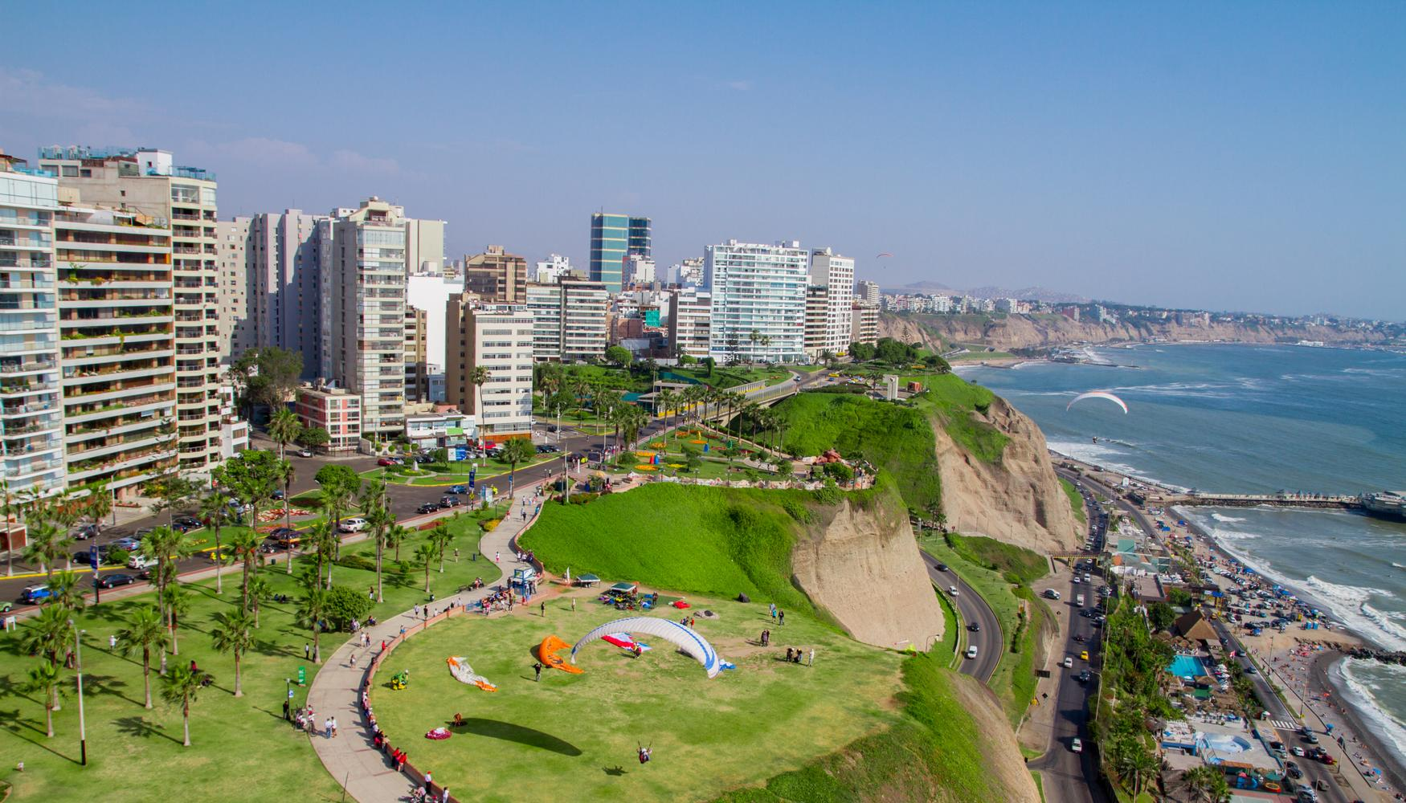
Figure 1. Costa Verde, Lima (Note – Figure captions should always be positioned below the figures)
Captions are set in 9-point type. If they are short, they are centered between the margins. Longer captions, covering more than one line, are justified. Captions that do not constitute a full sentence, do not have a period.
If screenshots are necessary, please make sure that the essential content is clear to the reader.
Remark 1. In the printed volumes, illustrations are generally black and white (half-tones). Coloured pictures are welcome in the electronic version free of charge. If you send coloured figures that are to be printed in black and white, please make sure that they really are also legible in black and white. Some colours show up very poorly when printed in black and white. Please refrain from using colour in text, tables or in equations.

Formulae. Displayed equations or formulae are centred and set on a separate line (with an extra line or half-line space above and below). Equations should be numbered for reference. The numbers should be consecutive within the contribution, with numbers enclosed in parentheses and set on the right margin. Please do not include section counters in the numbering.
x + y = z (1)

Footnotes. The superscript numeral used to refer to a footnote appears in the text either directly after the word to be discussed or – in relation to a phrase or a sentence – following the punctuation mark (comma, semicolon, or period). Please note that no footnotes may be included in the abstract.

Programme Code. Programme listings or programme commands in the text are normally set in typewriter font.

Citations by Number
Arabic numbers are used for citation, which is sequential either by order of citation or by alphabetical order of the references, depending on which sequence is used in the list of references. The reference numbers are given in brackets and are not superscript. Please observe the following guidelines:
- Single citation: [9]
- Multiple citations: [4-6, 9]. The numbers should be listed in numerical order.
- If an author’s name is used in the text: Miller [9] was the first …
Please write all references using the Latin alphabet. If the title of the book you are referring to is, e.g., in Russian or Chinese, then please write (in Russian) or (in Chinese) at the end of the transcript or translation of the title. All references cited in the text should be in the list of references and vice versa.
If more than six authors are listed in one particular reference, this will be shortened and “et al.” will be inserted.
In order to permit cross referencing within SpringerLink, and between different publishers and their online databases, Springer standardises the format of the references according to the requirements for CrossRef (http://www.crossref.org/). The reference section is included in the metadata of the paper on SpringerLink, increasing the visibility of the referenced papers and facilitating research considerably.
Springer strongly encourages you to include DOIs (Digital Object Identifiers) in your references. The DOI is a unique code allotted by the publisher to each online paper or journal article. It provides a stable way of finding published papers and their metadata. The insertion of DOIs increases the overall length of the references section.

The footnote numeral is set flush left and the text follows with the usual word spacing.

